Multiple-choice section – choose the correct answer

Question 1 [5.1]

In cm2, the area of a rectangle of length 8 cm and width 10 cm is:

A 18 B 32 C 40 D 80

Question 2 [5.1]

Using , the area of a circle of radius 5 m is approximately:

A 3.14 m2 B 78.53 m2 C 150 m2 D 314 m2

Question 3 [5.2]

Using  the surface area of the box shown is:

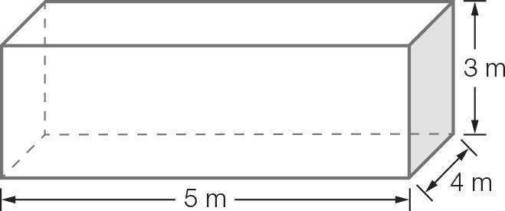

A 12 m2 B 24 m2 C 94 m2 D 104 m2

Question 4 [5.3]

A jewellery box has length 10 cm, width 6 cm and height 4 cm. Its volume is:

A 40 cm3 B 60 cm3 C 120 cm3 D 240 cm3

Question 5 [5.4] [10A]

The surface area of a cone of base radius *r* and slant length *s* is given by .   
The surface area (in cm2) of a cone with a radius of 6 cm and slant length of 4 cm is closest to:

A 190 B 244 C 525 D 1225

Question 6 [5.4] [10A]

Using , the surface area of a sphere of diameter 5 cm is, in cm2:

A 125.7 B 314.16 C 1257 D 3141.6

Question 7 [5.5] [10A]

Using , the cone’s volume to the nearest cm3 is closest to:

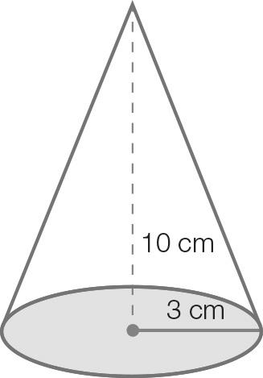

A 62.8 B 94.2 C 282.7 D 314.1

Question 8 [5.5] [10A]

A ball has radius 8 cm. Its volume in cm3, given by , is closest to:

A 101 B 1206 C 2145 D 21 445

Question 9 [5.7] [10A]

A rock of mass 2.1 kg has volume 300 cm3. Its density in g/cm3 is:

A 7 g/cm3 B 10 g/cm3 C 10 g/cm3 D 100 g/cm3

Question 10 [5.7] [10A]

10 L of salt water contains 160 mL of salt solution. The concentration of the salt water in mL/L is:

A 1.6 B 5 C 16 D 1600

Multiple-choice total marks: __ / 10

Short answer section

Question 11 2 marks [5.2, 5.4]

Use words from the list below to complete the following sentences.

surface area prism pyramid composite shape

capacity tapered solid density

(a) A three-dimensional shape whose cross-sectional area decreases uniformly is a __________________________.

(b) The____________________________________ of a cube is the sum of the area of its six faces

Question 12 3 marks [5.1]

Calculate the area of the shape (in m2).

(a) Explain why the following diagram is called a composite shape.

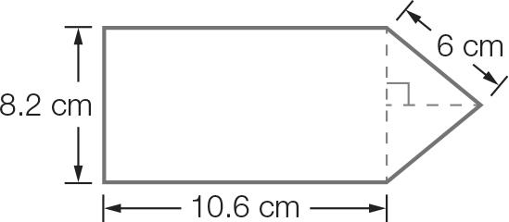

(b) Find the area of the composite shape by first finding the area of the triangle and rectangle.  
Give your answer correct to 1 decimal place.

Question 13 3 marks [5.1]

(a) Find the area of the square.

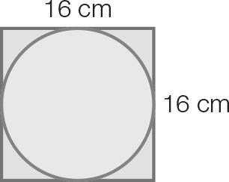

(b) Find the area of the circle correct to 2 decimal places.

(c) Find the area of the square not in the circle. Give your answer to the nearest cm2.

Question 14 3 marks [5.3]

Bernice has a small jewellery box shaped like this.

(a) How many different faces does this box have?

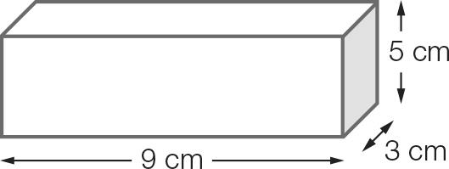

(b) Find the area of each of the faces. Use your answers to calculate the total surface area of the box.

Question 15 4 marks [5.5] [10A]

A square pyramid has a base of length 3 cm and a height of 12 cm.

(a) What is the area of the base?

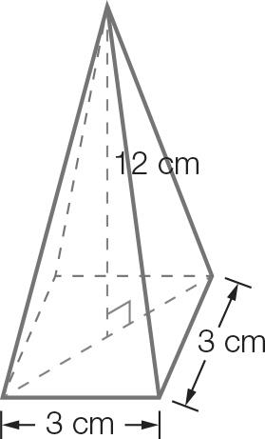

(b) What is the volume of the pyramid?

Question 16 3 marks [5.4] [10A]

The curved surface of a cone of radius 4 cm and slant length 9 cm is to be painted. Find the total surface area of a cone by using the formula: 

Using only the part of the formula that calculates the curved surface area, calculate the area to be painted to the nearest cm2.

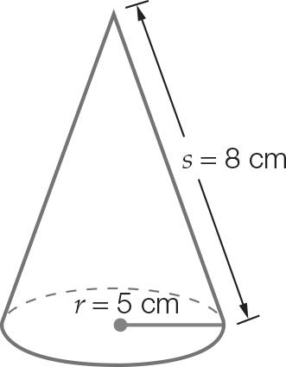

Question 17 3 marks [5.5] [10A]

A fruit bowl in the shape of a hemisphere has radius 14 cm. What is the volume of the bowl, to the nearest cubic centimetre?

Question 18 3 marks [5.2]

Use the formula  to find the surface area of the cylinder correct to 2 decimal places.

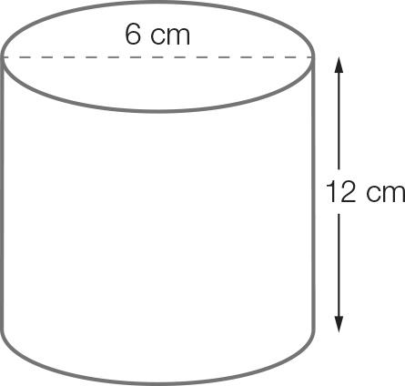

Question 19 3 marks [5.6]

(a) Rearrange the formula v = u + at to make t the subject.

(b) Find the value of t for v = 13, u = 1, a = 2.

Short answer total:_________/27

Extended answer section

Question 20 3 marks [5.2]

Ben has a can of baked beans. He measures the diameter to be 8 cm and the height to be 11 cm. He then carefully peels the label off the can and lays it out flat.

(a) What shape is the label?

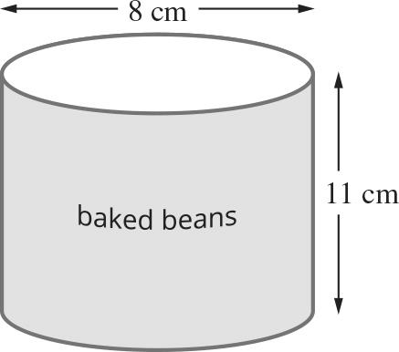

(b) What are the dimensions of the label, correct to the nearest centimetre?

(c) Find the area of the label, correct to the nearest square centimetre.

Question 21 5 marks [5.3]

A swimming pool has the shape of a rectangular prism of length 20 m, width 4 m and   
height 2.4 m.

(a) What is the volume of the pool, in cubic metres?

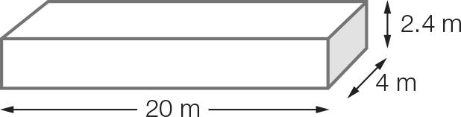

(b) The pool is filled with water to a height 40 cm below the maximum possible height. What is the capacity of the pool, in litres?

(c) The four inside walls and the bottom of the pool are to be tiled. By working out the area of each rectangular shape, work out the total area that needs to be covered, in square metres.

Extended answer total:______/8

TOTAL test results: _____ / 45